# SP300x/DC-4/GEDC-6 – Technical Bulletin - 001

Update of the World Magnetic Model (WMM) to the latest Coefficients.

# Introduction

This technical bulletin describes how to update the World Magnetic Model used to compute True North heading and enhanced 2D calibration.

# Background

The DC-4/GEDC-6 devices have a default World Magnetic Model when shipped from the factory. Every 5 years (2005, 2010, 2015, …) these coefficients are updated to provide a more recent and accurate model of the magnetic pole locations and the magnetic variation spanning the globe. This magnetic model is easily updated with a new and more current model in one of two ways: updating to the latest firmware or simply updating the WMM coefficients. The World Magnetic Model provides declination angles to provide accurate True North heading as well as enhancing the 2D calibration when latitude, longitude, altitude and date is available.

# Required Documents

For DC-4/GEDC-6 users:

AN-1006 Firmware Upgrades with Flash Magic

AN-1004 Recommended Circuit for Firmware Upgrades

For SP300x users:

Sparton User Interface Manual (V7.1)

**Updating the Model**

*DC-4/GEDC-6 users:*

There will not be a newer firmware version for the GEDC-6 and DC-4 series. You can update the WMM by sending the WMM_2015.4th file located on the website over the serial port.

The Spartacus Software (formerly NDS-2) contains the ability to send a NorthTek script (text file) to the system. Please follow the following directions to update the WMM to the new 2015 coefficients.

1. Go to Spartacus Software ->Serial Terminal Settings and click on that selection

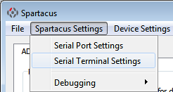

1. Verify the following settings:

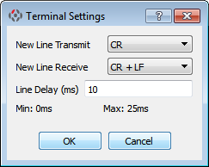

1. Go to File->Send NorthTek Script and click on that selection.

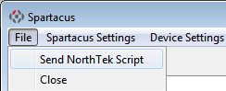

1. Go to the WMM_2015_pre_4_3_2_firmware.4th file location and select that file. You will see the coefficients streaming to the sensor. Once the data stream is finished, check the Basic Terminal Window to see if any “Huh?”s appear in the dialog. This would indicate that there was an error in the data transfer.
2. Once the transfer is complete with no errors, the new coefficients are ready to use!!!

You can also perform the same action with a simple terminal emulator and send the file as text or even use your own system to send the ASCII data.

*SP300x users:*

There will not be a newer firmware version for the SP300x series digital compass. You can update the WMM by sending the WMM_2015.COF file using the Sparton Compass Magnetic Update software located in the downloads section of the our website.

The procedure is as described in the Sparton User Interface Manual (V7.1) located in the legacy section of the website.

1. Download the WMM_2015.COF file from the downloads section of our website
2. Install the Sparton Compass Magnetic Update software
3. Go to the location of the new COF file and select the 2015 version
4. Once the coefficients have been updated, the software will verify that they match the original file.

**Want to know more?**

* Check it out here: [www.spartonnavex.com](http://www.spartonnavex.com)

Or email us at: [productsupport@sparton.com](mailto:productsupport@sparton.com)